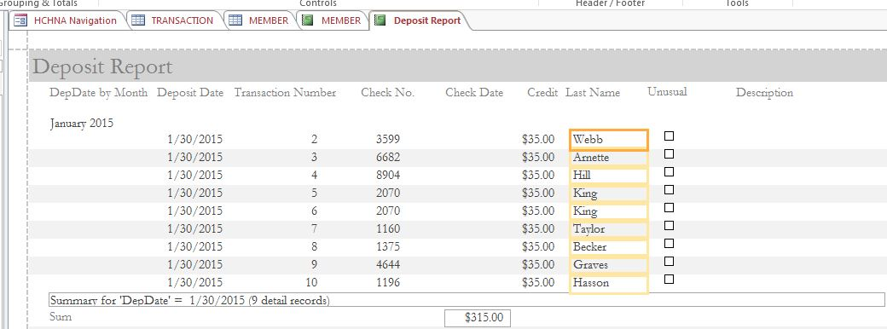

Report Name: Deposit Report

Created by: Donna Walker

Prepared for: Treasurer

Navigation Pane Location: ??

Query: Deposit Query list parameter that are required to run this report

Purpose: Provides details of transactions included in each deposit. The report summarizes by the month.

Report Name

Created by

Prepared for: ex- membership, a specific officer, or a specific officer for membership distribution

Switchboard Location: Instructors/Student Reports…/Absent Students

Query: Query name and should list parameter that are required to run this report

Purpose: